SmartPlant 3D-SmartSketch
Drawing Editor Basics

Drawings Editor (SmartSketch) Basics 3
Creating Graphics with Drawing Editor 12
The Select Tool, Find Command and Modification Tools 22
Text and Annotations 34
Dimension Tools 42
Drawing Editor Symbols 46

Drawings Editor (SmartSketch) Basics

Where to find Drawings Editor inside SmartPlant 3D
By default, SmartPlant 3D does not have an icon to initiate the Drawing Editor application. A shortcut must be created to access the Drawing Editor application.
Create a shortcut to the Drawing Editor, go to the following directory: C:\ProgramFiles\SmartPlant\3D\Common2D\Shape2D\Bin\Shape2Dserver.exe and put the shortcut in Start Menu>Programs>Intergraph SmartPlant 3D or on the desktop.
Setting up Properties for a Document
Properties on the File menu allows you to view, edit, and store properties for a document. Document properties can include the title, the author, and keywords that identify important information. These properties also can include document statistics, such as document size and the date that a document was created and last modified. Some properties, such as the date the document was last modified, are updated automatically.
To set the properties, you can click the Properties command on the File menu.
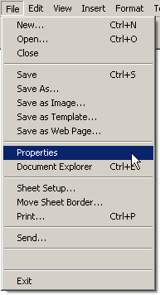

Note: You can also right click on a blank area of the drawing to access Properties from the shortcut menu.
Units Tab
The units of measure settings for a document are stored as a property. If the units of measure are changed, all subsequent measurements entered and displayed are affected.
Units of measure can be set in either Imperial or Metric units for values such as length, area, or angle. The units of measure can be changed at any time and the document still retains complete accuracy of the objects already placed on the drawing. Set the length readout precision to 3-digit:
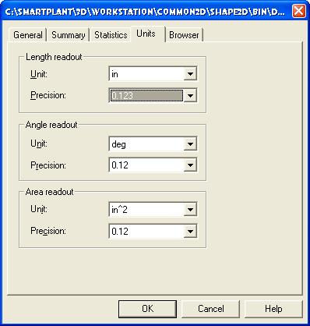

Length Readout
Sets the unit of measure and precision readout for the length values in a document.

Angle Readout
Sets the unit of measure and precision readout for the angle values in a document.

Area Readout
Sets the unit of measure and precision readout for the area values in a document.

Precision
The precision readout sets the number of significant figures to display. It sets the accuracy of the unit readout value. The precision setting does not alter the numbers that you type into the fields, only the display of the numbers in the field. Values ending in 5 are rounded up. For example, if the precision readout is .123 and you draw a line that is 2.1056 inches long, then the line value length is rounded. The length value appears as 2.106 inches long. If you are using mm as your drawing sheet units, you can have the values display in the fields as 3.5 mm or 3.50 mm.

Note: When you set the units of measure for a document, the settings do not affect the dimensional values for the document. You can set units for the dimensional values with the Dimension Properties dialog box. You can access this dialog box by selecting a dimension and then clicking the Properties command on the shortcut menu. You can also set the dimension units by editing a dimension style with the Dimension command on the Format menu.

Working Sheets
Working sheets are similar to pages in a notebook. Sketches or drawings can be placed on different drawing sheets in the document. For example, one idea can be drawn for a design on one drawing sheet and another idea on another drawing sheet. Both drawings are saved as part of the same document.

Working Sheet Setup

Each working sheet has its own setup. Working sheet characteristics, such as the size and scale of the sheet, can be modified with the Sheet Setup command from the File menu. After setting the options on the Sheet Setup dialog box and then selecting the Save Defaults button, all new sheets will have the same characteristics.

Access the sheet setup dialog box by selecting sheet setup from one of the following:

- From the File menu, select Sheet Setup.
- Position the mouse pointer over a selected sheet, click the right mouse button, and select Sheet Setup from the shortcut menu, or just double left click on the sheet tab.

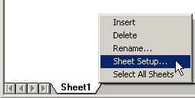

When the scale is specified using the Sheet Setup command from the File menu, everything on the sheet is scaled except dimensions and annotations. For example, if the scale is one inch to ten inches (1:10) and a line 30 inches long is placed, the line is three inches long in proportion to the sheet and three inches long when printed. However, a dimension measures the length of the line as 30 inches.
Dimension and annotation sizes in the sheets are independent of the view scale. For example, the height of dimension text will be printed at the specified size regardless of their screen appearance.

Graphics elements on the attached background sheet are always displayed at a 1:1 scale. They are not affected by the scale factor for the working Sheet Setup command.

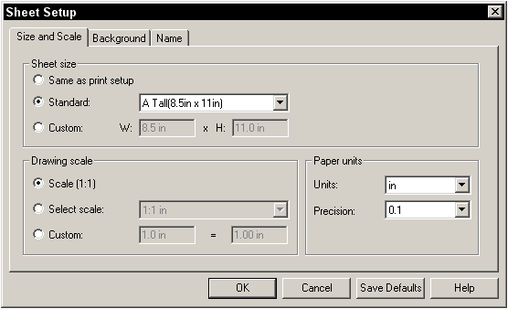

Size and Scale Tab
Defines the details for the drawing sheet size, scale, and print setup information.

Sheet Size
Sets the size of the drawing sheet.

Same as Print setup
Sets the drawing sheet size using the current print setup definition. For example, if the printer is set up as 8 1/2 X 11, the drawing sheet size is set up as 8 1/2 X 11.

Standard
Defines the drawing sheet size from a list of standard ANSI and ISO paper sizes.

Custom
Defines the drawing sheet size according to the entered x and y values.

Drawing Scale
Sets options for the scale of the drawing sheet.

Scale (1:1)
Sets the drawing scale to a 1:1 ratio. This means that the representation of the object on the drawing sheet is the same size as the real-world object being described.

Select scale
Sets the drawing scale to a standard ratio. The specified ratio defines the size of the drawing in relation to the size of the real-world object. For a 2:1 ratio, the 2 represents the size of the drawing and the 1 represents the size of the real-world object.

Custom
Defines a custom scale ratio. The first value defines the distance on the drawing sheet and the second value defines what the distance is equal to in the real world.

Paper Units
Sets the paper units for the drawing sheet.

Units
Controls the display of numeric values in dialog boxes that define the size of non-scaled objects. Some examples of non-scaled object values are text height and line width. This setting has no affect on dimension units.
Only value boxes use this option. For example, if working in feet and inches, the user can specify to read and enter values for text height in fractional inches.
(1/8" instead of 0.00'-0.125")

Precision
Sets the number of significant digits to display, or the accuracy of the unit read-out value. The precision setting does not alter the numbers that can be typed into the fields, only the display of the numbers in the fields.

For example, if you set this control to .001 and you draw a line that is 2.1056 inches, then the line length value is rounded. The length value appears as 2.106 inches. If you set this control to 0.01 and you type a line length value of 3.5 mm, the length value appears as 3.50 mm.

Layers

Layers can help group elements so they can be manipulated more easily on a drawing sheet. Layers also make it easier to keep track of different types of elements. Each drawing sheet in a document can contain many layers. This is similar to each sheet having many transparencies.

When drawing an element, it is assigned to the active layer. To see which layer is active, or to change the active layer, use the Layers command from the Tools menu.

Displaying Layers
To view elements on specific layers, layers can be turned on or off with the Layers command from the Tools menu or by clicking the Layers icon on the Main toolbar.

When turning layers off, the elements assigned to those layers on the drawing sheet cannot be seen. For example, you can assign lines to one layer and closed elements to another layer. If you turn off the layer for the closed elements, you see only lines on the drawing sheet.

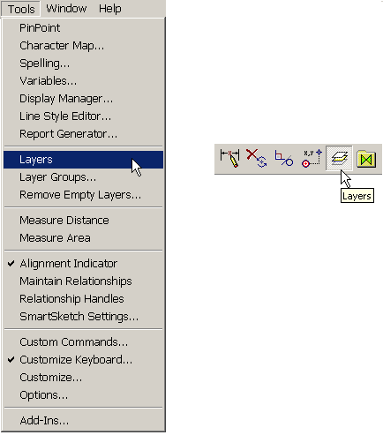

Layer Ribbon Bar
The Layer ribbon bar is used to display the active layer, create new layers, change the active layer for drawing or for elements, and display the layer status.
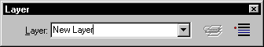

Active Layer
Displays the active layer on the drawing sheet. The active layer can be changed by selecting from a list of all the layers on the active sheet. To create a new layer, type the name of the new layer in the Layer box and press Enter

Change Layer
Accesses the Change Layer dialog box so that the layer of element(s) can be changed. This option is available only when elements on the drawing sheet have been selected.

Layer Display
Accesses the Layer Display dialog box. This dialog box has a layer list that can be used to display or hide layers on the drawing sheet.

Relationships are maintained between elements that are assigned to different layers on a drawing sheet. For example, suppose a line and a circle are tangent and they are assigned to different layers. If the line's layer is displayed and the circle's layer is hidden, you can still see the tangent relationship handle on the line. If the line's layer is hidden as well, the tangent relationship handle is hidden.

Grid Display in Drawing Editor

Placing Elements with a Grid: An Overview

The grid and its grid lines allow elements in the document to be placed by aligning them with the grid lines or nearest intersection of the grid lines. The grid can be used to line up elements at regular intervals in a document. The options to set up the grid can be found by going to the Tools>Options dialog box, and selecting the View tab.

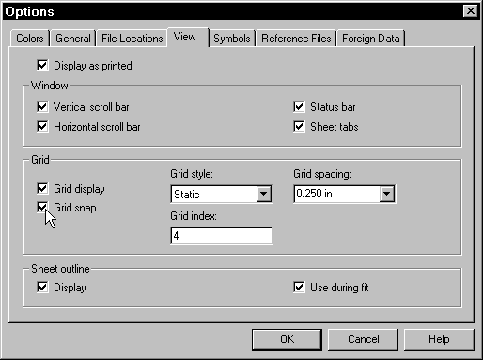

Grid Display
Displays a grid so that elements can be placed with precision. The grid lines are visual aids but are not considered part of the document and do not print.

Grid Snap
Aligns elements with the grid while it is active. The grid can be used as an invisible set of lines in the document that helps to align elements. When Grid Snap is set, but the display is off, elements always align with the nearest intersection of the grid lines whether they are visible or not.

Note:
- Grid snap does not work while you identify elements that are aligned along grid lines. To override this, press the Alt key while identifying these elements.

- Relationship and alignment indicators override the grid snap. You can suppress the indicators by pressing Alt.

Grid Style
Changes the format of the grid lines to either static or dynamic.

Zooming in or out, the software dynamically generates the grid lines for a dynamic grid. Set dynamic grid lines to appear at fine, medium, or coarse levels using the Grid Density setting (see below). The grid lines appear at common major measurement increments. A dynamic grid displays index lines that intersect with the darker, solid grid lines.

A static grid displays solid grid lines that do not move as you zoom in or out. The grid maintains a constant minimum spacing.

Grid Index
Determines the number of index grid lines, also known as minor grid lines, to be equally spaced between the major grid lines. This option is available only if you select Static in the Grid Style list box.

Grid Spacing
Sets the spacing of the major grid lines. This option is available only if Static is selected in the Grid Style list box. The selected options on the Units tab of the Properties dialog box determine the units that can be entered, such as inches or centimeters.

Grid Density
Changes the number of dashes in the index lines, or minor grid lines, between intersections with the grid lines. This option is available only if Dynamic is selected in the Grid Style list box.

Turn On or Off Grid Display and Grid Snap
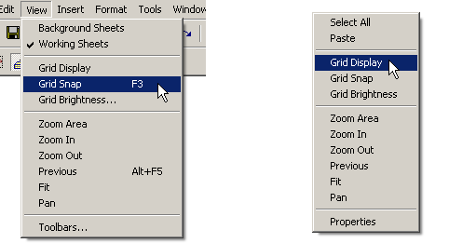

Grid Display and Grid Snap can also be turned on and off from the right-click shortcut menu or by going to the View pull-down menu.

Creating Graphics with Drawing Editor

The Draw Toolbar

Many drawing commands are located on the Draw toolbar. On the toolbar, some command buttons may display fly-outs when you click and hold the command button on them. These buttons have a small black arrow in the lower right corner. Fly-outs present a grouping of commands functionally related to the original command displayed.
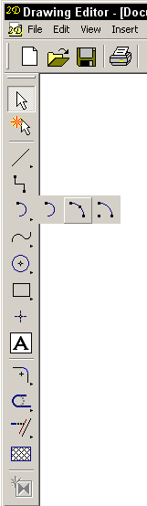
Fly-out Menu

Line
Draws one line or a series of connected lines. The Line Fly-out menu contains two additional tools that may be used to draw linear elements: Line/Arc Continuous and Place Double Line.

Tangent Arc
Draws an arc tangent or perpendicular to one or two elements. The Arc Fly-out menu contains two additional arc drawing tools: Arc by Edge and Arc by Center Point.

Curve
Draws a smooth, open or closed curve.

Circle by Center Point
Draws a circle using a center point and radius. The Circle / Ellipse Fly-out menu contains several additional commands: Circle by 3 Points, Tangent Circle Command, Ellipse by Center Point and Ellipse by 3 Points.

Rectangle
Draws a rectangle using three points. The first two points define the width and rotation angle of the rectangle, and the third point defines the height. The first two points define the width and rotation angle of the rectangle, and the third point defines the height.

Point
Places a point in the drawing.

Using the Line command:
- From the Draw toolbar, select the Line tool.

- Place a point on the drawing sheet to define the start of the line. (1)

- Click where the line is to end. (2) This defines the line’s length.

- Do one of the following:

  - To end the line, press the right mouse button or press the <Esc> key.

  - To draw a series of connected lines, click where each line segment is to end and then click the right mouse button.
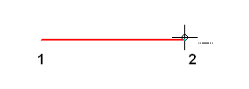
Values can be typed in the Length or Angle fields on the ribbon bar. A combination of graphic and ribbon bar input can be used.

To draw an arc tangent to an element
- From the Draw toolbar, select the Tangent Arc tool.

- Select a point on the element that the new arc is to be tangent to. This can be a point on a line, an arc, or any curved element.

- Pass the mouse cursor through one of the intent zones displayed at the position just selected. If the command dynamics show an arc perpendicular to the existing element, move the mouse cursor back to the intent zones and exit through a different quadrant. The quadrant selected also determines the side of the element where the arc appears.

- When the command dynamics show the arc you want, press the left mouse button.
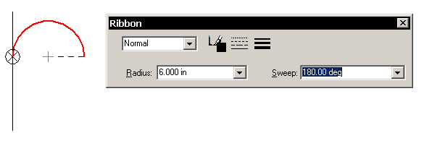
Note: The mouse cursor can be dragged to draw an arc. Instead of clicking to define the radius and sweep of the arc, values can be typed in the Radius and Sweep boxes on the ribbon bar. A combination of graphic and ribbon bar input can be used. Drawing Editor indicators and PinPoint can also be used with this command.

How PinPoint Works
PinPoint provides coordinate input to drawing commands. The x and y coordinates are relative to a target point that can be positioned anywhere in the application window. The location of the target point can be changed at any time by selecting the Reposition Target button on the ribbon bar and then clicking a new position in the application window.

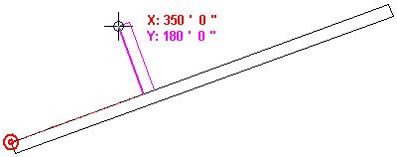

PinPoint

To start PinPoint, click the PinPoint command from the Tools menu or select the PinPoint command from the Main toolbar.

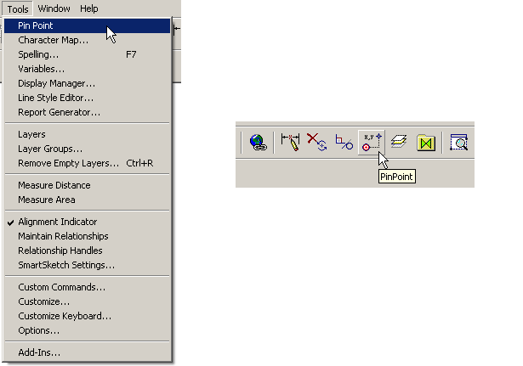
Main Toolbar

PinPoint Ribbon Bar

Display On/Off
Displays or hides the PinPoint help lines and distance values. F9 is a shortcut toggle.

Reposition Target
Attaches the target point to the cursor so that it can be repositioned. Used to select where the target point is to be. F12 can be used as an alternate method to move the target.

Relative Tracking
If activated the PinPoint target will move to the last point clicked while using the drawing tools.

Define PinPoint Origin
Allows the user to locate the origin in X,Y coordinate points for the document using the Define PinPoint Origin ribbon bar. The Save PinPoint Origin button on the ribbon must then be pressed in order to save this defined origin position within the document.
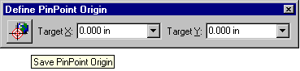

Reposition Target to Origin
Moves the PinPoint target to the X,Y position that was saved using the Save PinPoint Origin on the Define PinPoint Origin ribbon bar.

Angle
Specifies the angle of the PinPoint X-axis relative to its default horizontal orientation. Positive values rotate the horizontal line counterclockwise. Negative values rotate the horizontal line clockwise.

Step
Specifies the PinPoint step value. The step value is an incremental distance along the PinPoint coordinate axes. When the distance between the target position and the current cursor location is an increment of the step value, the related coordinate value and help line become bold. This can be useful to maintain consistent spacing between elements.

X
Locks the horizontal distance between the target point and the current cursor location to the value specified. F10 is a shortcut toggle for this lock setting.

Y
Locks the vertical distance between the target point and the current cursor location to the value specified. F11 is a toggle to lock/unlock this setting.

When moving the cursor, PinPoint dynamically displays the horizontal and vertical distance between the current cursor location and the target point. Help lines show the PinPoint X and Y axes and the PinPoint orientation.

Locking and Freeing Values

The X coordinate and/or Y coordinate can be locked using the X and Y boxes on the ribbon bar. When one coordinate value is locked, the other coordinate value can be positioned by selecting a location in the application window or setting both values using the ribbon bar boxes. If you want to free the dynamics for a locked value, clear the value box by double-clicking in the box and pressing the Backspace or Delete key.

PinPoint Orientation
In its default orientation, the PinPoint X-axis is horizontal. To re-orient it to any angle, set the angle on the PinPoint ribbon bar. The figure shows the PinPoint angle set to 20 degrees.

PinPoint Reposition
Do one of the following:
- On the PinPoint ribbon bar, click the Reposition Target button. The target point is attached to the cursor. Select where the target point is to be.

- Press the F12 key on the keyboard. The target point moves to the current cursor location.

Draw with PinPoint
  - From the Main toolbar, select PinPoint .
  - Click where the target point is to be. (1) Or use Esc to set it to 0,0 on the sheet.
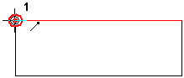

  - Select any drawing command. When moving the cursor, PinPoint displays the coordinates of the current cursor location in relation to the target point (2), (3). To provide precision input to the current command, press when the coordinate display indicates that the cursor is in the correct position or type coordinate values in the X and Y ribbon bar boxes.

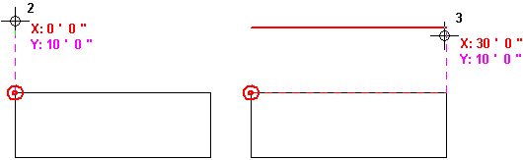

Notes:
- When the cursor reaches a distance from the target point that is a multiple of the Step value set on the ribbon bar, the related coordinate value and help line become bold.

- If the exact x and y distances are known from the target point that is to be used as the command input, type the values in the X and Y ribbon bar boxes.

- A known x or y value can be typed into the X or Y ribbon bar box to lock one axis position, then graphically define the coordinate for the other axis.

- The target point can be moved at any time. Select the Reposition Target button on the ribbon bar, and then click where the target point is to be.

- The PinPoint x-axis can be re-oriented. Type a positive value in the PinPoint Angle box on the ribbon bar to rotate the axis counterclockwise, or a negative value to rotate the axis clockwise.

Move an Element with PinPoint and the Select Tool

PinPoint can be used with the Select Tool to move an element a precise distance in x and y relative to a known position in the drawing.
- From the Draw toolbar, click the Select Tool .
- From the Main toolbar, select PinPoint .
- Select where the PinPoint target point is to be. (1)

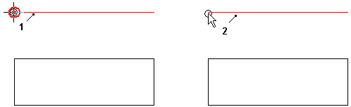

- Position the Select Tool cursor over the element to be moved. (2) Drawing Editor indicators can be used to locate keypoints on the element.
- When Drawing Editor indicates the keypoint to be used as the handle point for the move operation, begin dragging the element. PinPoint displays the distance between the target point and the reference point as you drag. (3)

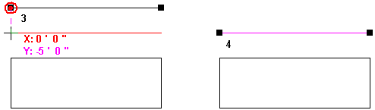
- Release the mouse button when the element is in the desired location. (4)
- Click away from the element that was moved to deselect the element.

SmartSketch Settings (Drawing with Relationships)

SmartSketch Settings are dynamic drawing aids that help create technically sophisticated drawings quickly and easily. These settings can be used with any drawing command. When drawing, Drawing Editor tracks the movement of the mouse cursor and shows a temporary, dynamic display of the element being drawn. This temporary display shows what the new element will look like when clicking at the current position.

Drawing Editor gives information about the element being drawn by displaying relationships between the temporary dynamic element and the following:

- Other elements in the drawing
- Horizontal and vertical orientations
- The origin of the element you are drawing

When Drawing Editor recognizes a relationship, it displays a relationship indicator at the mouse cursor. As the mouse cursor is moved, Drawing Editor will update the indicator to show new relationships. If a relationship indicator is displayed at the cursor when clicking to draw the element, the software can apply that relationship to the element (if Maintain Relationships is active). For example, if the Horizontal relationship indicator is displayed when you click to place the second end point of a line, then the line will be exactly horizontal.

To suspend SmartSketch Settings

- Hold down the <Alt> key on the keyboard. Drawing Editor does not recognize any relationships while holding down this key.

- Release the <Alt> key to reactivate SmartSketch Settings.

Relationship Indicators

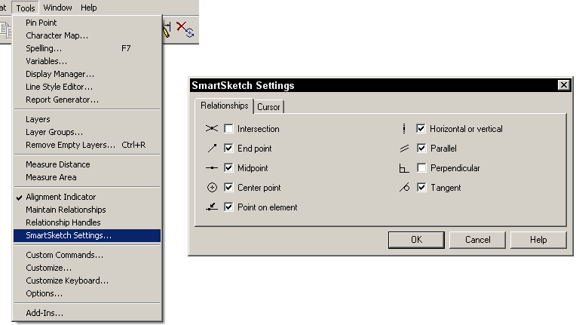
Intersection
Displays when you are at the intersection of two elements.

End point
Displays when you are at the end point of an element.

Midpoint
Displays when you are at the midpoint of an element.

Center point
Displays when you are at the center of a circle or an arc.

Point on element
Displays when you are at any point on an element.

Horizontal or Vertical
If the Horizontal relationship indicator displays when drawing a line, when clicking to place the second end point of the line, the line will be exactly horizontal. If the Vertical relationship indicator displays when drawing a line, when pressing to place the second end point of the line, it will be exactly vertical.

Parallel
Displays when a parallel relationship exists between two elements.

Perpendicular
Displays when a perpendicular relationship is recognized.

Tangent
Displays when a point of tangency is passed through.

Drawing with the SmartSketch Settings example:
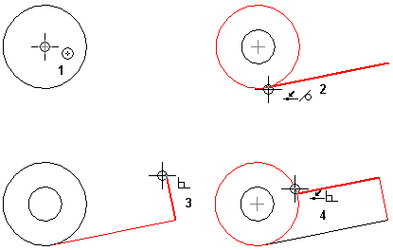

How Relationships Work

An element that has no maintained relationships applied to it can be moved and changed in various ways. For example, when there are no maintained relationships between two lines (A), each line can be moved and changed without affecting the other. If applying a perpendicular relationship between the two lines (B) and moving one line, the other line moves with it.
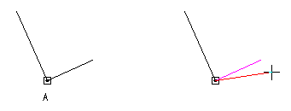
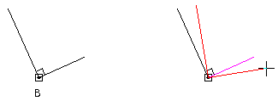
When applying a relationship between elements, the relationship is maintained when modifying either element. For example:

- If a line and an arc share a tangent relationship, they remain tangent when either element is modified.
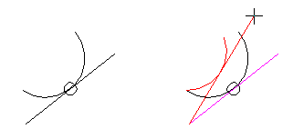
- If a line and an arc share a connect relationship, they remain connected when either element is modified.
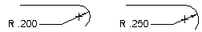

The Select Tool, Find Command and Modification Tools

Select Tool
The Select Tool can be used to select a single element, a group of elements, or all elements that lie within a specified area.

When an individual element is selected, the element changes to the selection color and the element’s handles are displayed. Handles are solid squares at significant geometry positions on a selected element, such as end points and center points. Handles allow you to directly modify an element by dragging a handle to change the element's shape. Although more than one element can be selected at a time, only one element can display handles. When you select multiple elements or grouped elements, they change to the selection color.

Select Tool Ribbon Bar

The ribbon bar contains settings that allow the user to determine if the elements selected must be completely enclosed by the fence (the inside setting), or if the overlap feature is activated then the fence need only touch a portion of an element for it to be selected. Many manipulation commands, like delete, move, copy, and rotate, act upon all elements in the selection set.

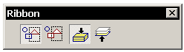
Inside
(Default) Only elements that lie entirely inside the fence are selected.

Overlapping
Elements that lie inside and elements that overlap any portion of the fence are selected.

Top Down
(Default) Specifies that groups of elements are located as opposed to individual elements
in a group.

Bottom Up
Specifies that individual elements in a group are located as opposed to the whole group.

Polygon Fence Locate

The Polygon Fence Locate tool creates a select set by drawing a rectangular or polygonal fence around objects based on points that you define.

Polygon Fence Locate Ribbon Bar

The ribbon bar contains settings that allow the user to select a rectangular fence shape or user-defined polygon fence shape.
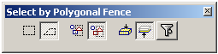

Rectangle
Creates a select area, or fence, by drawing a rectangle around points that you define. When you drag the mouse to define a rectangular fence, a dashed rectangular outline dynamically appears as you drag. When you reach the desired size, release the mouse button to create the fence. The dashed fence outline disappears and the elements are selected.

Polygon
Creates a select area, or fence, by drawing a polygon around points that you define. Following the first point, click the remaining points to define the polygon. Points are placed when you release the mouse button. Right-click to end the polygon. The dotted outline disappears and the elements are selected.

Inside
Specifies that elements inside the fence are selected.

Overlapping
Specifies that elements overlapped by the fence are selected, as well as elements inside
the fence.

Top Down
Specifies that groups of elements are located as opposed to individual elements in a group.

Bottom Up
Specifies that individual elements in a group are located as opposed to the whole group.

Locate Filter
Opens the Define Filter Locate dialog box where you can specify a filter for the selection of specific drawing elements. Filters allow you to select specific types of drawing elements, or all drawing elements.

PickQuick
PickQuick aids the selection of individual elements when there are several clustered very tightly together. If the cursor is placed where multiple elements overlap, three ellipses will appear at the lower right of the cursor. When the left button is pressed, a numbered toolbar appears. As the cursor slides over a number, the corresponding element highlights. Picking that number selects the corresponding element.

In Drawing Editor, elements may be pre-selected for manipulation, which sometimes makes manipulation easier. The manipulation of several elements at the same time is also made easier by pre-selection.

To select an element with PickQuick

- Position the cursor over the elements to be selected from and pause the cursor there.
- When the cursor changes to an ellipsis (three dots), click. The software displays the Selection toolbar near the cursor, with a button for each selectable element.
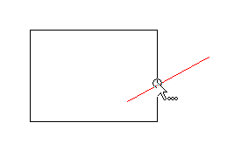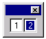
- Move the cursor over the PickQuick buttons without clicking to highlight the corresponding elements.
- Click on the desired number to select the corresponding element.

Find

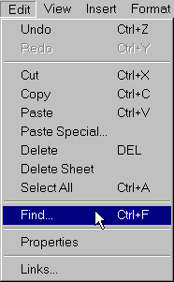
Searches for objects within a Drawing Editor document based upon user-defined criteria. The Find command can be used to locate geometric elements and symbols that have a specific format or a specific set of defined attributes.

First, define the search criteria in the Find dialog box, and then execute the search. Items that match the defined criteria appear selected on the Drawing sheet.

Find a Drawing Editor Object

- Click Edit > Find or press Ctrl + F keys to execute the Find command.

- In the Find dialog box, use the options on the various tabs to define the search criteria.

- Click Find Now to execute the search.

Notes:
  - Objects that match the specified search criteria appear as selected on the Drawing Editor Drawing sheet. These objects are added to the select set.
  - Tools > Customize can be used to place the Find button 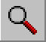 on a toolbar.

Type Tab

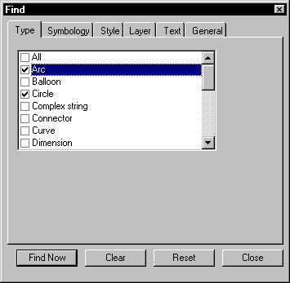

Type

Specifies the type of Drawing Editor element, object, or attribute to be located. It is possible to define the parameters of the search to encompass a wide-range of items, including geometric elements, Drawing Editor symbols, or a variety of attributes.
Find Now
Executes the search based on the criteria specified. When found, the matching object appears highlighted on the active Drawing sheet.

Clear
Clears out the results of the last search conducted. All items that appeared selected in the Drawing Editor drawing are deselected.

Reset
Returns the options on each of the Find dialog box tabs to their default settings.

Symbology Tab

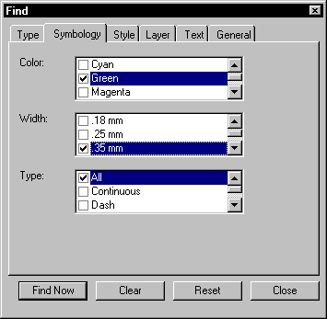

Symbology
Sets options for performing a search based on color, line weight, and line type.

Color
Specifies the drawing color used in the search criteria.

Width
Defines the line width used in the search criteria.

Type
Specifies the drawing line type used in the search criteria.

Style Tab

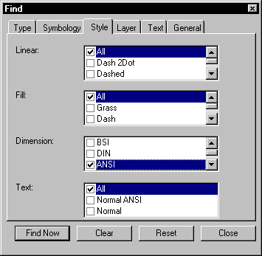

Style
Defines search criteria based on style attributes.

Linear
Specifies the linestyle used in the search criteria.

Fill
Specifies the type of fill used in the search criteria.

Dimension
Specifies the type of dimension used in the search criteria.

Text
Specifies the type of text used in the search criteria.

Layer Tab

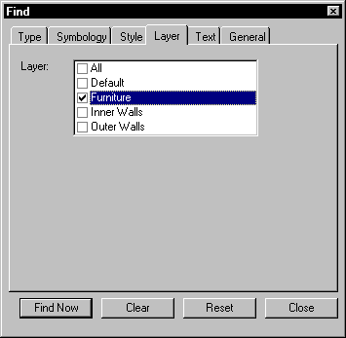

Specifies which layers of the Drawing Editor document to conduct the search on. Two options are available by default - All layers or the Default layer; however, if additional layers have been created in the Drawing Editor document, they are also displayed.

Note: For more information concerning layers, see Lesson 8.

Text Tab

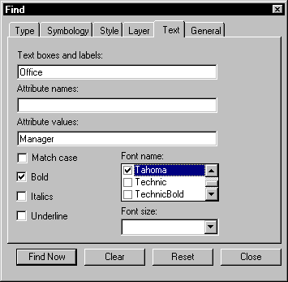

Sets search criteria based upon text-based options.

Text boxes and labels
Specifies the text string used in the search criteria.

Attribute names
Specifies the attribute name used in the search criteria.

Attribute values
Specifies the attribute value used in the search criteria.

Match case
Limits the search criteria to include only the text with the same capitalization as the Text
boxes and labels text.

Bold
Limits the search criteria to include only text that is bold.

Italics
Limits the search criteria to include only text that is italicized.

Underline
Limits the search criteria to include only text that is underlined.

Font name
Limits the search criteria to include only text that matches the font name specified.

Font size
Limits the search criteria to include only text that matches the font size specified.

Note: For more information concerning text, see Lesson 9.
General Tab

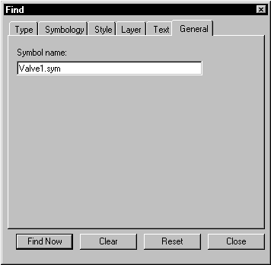

Refines the search criteria to include a specific symbol name.

Symbol name

Specifies the name of the symbol to be located when the search executes.

Offset

Draws an offset copy of an element or a set of contiguous elements. This command copies elements while maintaining characteristics such as the angle of lines and the center point of arcs and circles.

Offset copies the original element at a specified distance. Offsetting outside the perimeter of the original element creates a larger element. Offsetting inside the perimeter of the original element creates a smaller element.
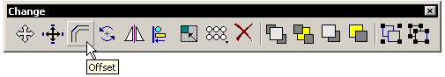
Offset Ribbon Bar

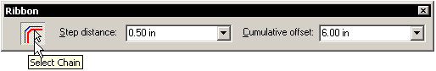

Select Chain
If on, this option will offset a chain of all continuous elements.

If it is not active, Offset copies only the selected element, (this is the default setting).

Step Distance
Sets the distance from the base element to the offset copy.

Cumulative Offset
Displays or sets the total distance of the current offset graphic element from the original graphic element.

Offset Example:
- Select the Offset tool and make sure that the Select Chain option is on.

- Set the step increment for the offset from the ribbon bar.

- Select the item to be offset and move the mouse in the direction for the offset.

- Accept the offset distance with the left mouse button.
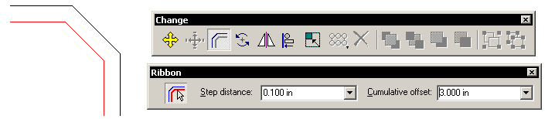
If the Select Chain option is turned off you will get the following result:
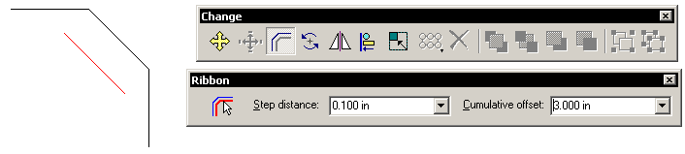

Align

- This tool will align two or more objects in a select set.

- If the Change toolbar is not active, activate it by selecting the Change button from the Main toolbar.
- From the Change toolbar, select the Align tool. On the drawing sheet, select two or more objects that you want to align.
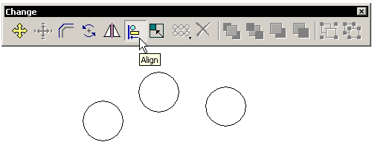
Before
- On the Align ribbon, click the button that corresponds to the alignment type you want.
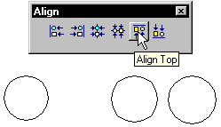
After

Notes:
- When using horizontal alignment, make sure the selected objects are not to the top or bottom of one another. If two shapes are vertically near one another, one of the objects may be placed behind another object.

- When using vertical alignment, make sure the selected objects are not to the right or left of one another. If two shapes are horizontally near one another, one of the objects may be placed behind another object.

- Alignment features only line up objects; they do not distribute an equal amount of space between aligned objects.

- Items that are glued to other objects cannot be aligned, including labels and symbols.

Align Ribbon Bar Options
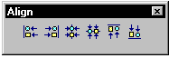

Align Left
Aligns the left side of objects in a select set.

Align Right
Aligns the right side of objects in a select set.
Align about Vertical
Aligns the objects in a select set along their vertical centers.

Align about Horizontal
Aligns the objects in a select set along their horizontal centers.

Align Top
Aligns the tops of objects in a select set.

Align Bottom
Aligns the bottoms of objects in a select set.

Text and Annotations

Text Box Commands

The Text Box command is used to place a text box in a document. A text box can be a single line of text, multiple lines of text, text boxes with a defined width, or text within a border.

Text Box Ribbon Bar
The Text Box ribbon bar is used to format a text box.

Font
Font Size
Style

Style
Lists and applies the available styles.

Font
Lists and applies the available fonts.

Font Size
Applies a text size in the actual paper size (i.e. not scaled).
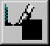 Text Color
Sets the color for the font.

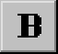 Bold
Makes the text bold.

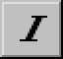 Italic
Italicizes the text.

 Underline
Underlines the text.

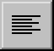 Paragraph Alignment
Positions the paragraph to the left, center, or right of the text box in edit mode.
The paragraph alignment can also be modified after placement by selecting it and changing the setting on the ribbon bar.
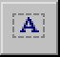 Border
Permits three options for displaying borders around the text boxes. These options allow you to display no border, display a border, or display a border with a shadow.

Text Ribbon Bar (Extended)

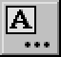 More
Displays more options on the Text Extended ribbon bar.

Text Box Height
Text Box Width
Text Box Angle

Height
Sets the height of the text box.

Width
Sets the width of the text box.

Notes on width:
- If you select text in the text box, Height and Width are not available because the text is driving the dimension.
- If you select a text box and Height is not available, the text is driving Height with the Auto Save option. The same is true for Width.

- If you place a text box with a single point, both Height and Width are not available. If you drag a text box, Width is not available.

Angle
Sets the angle of the text box.

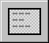 Horizontal Text Orientation
Specifies that the text is oriented horizontally in the document.

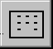 Vertical Text Orientation
Specifies that the text is oriented vertically in the document.

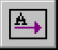 Left To Right
Specifies that the characters in a text box be displayed from left to right, as you would see in an English paragraph.

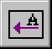 Right To Left
Specifies that the characters in a text box are displayed from right to left, as you would see in an Arabic or Japanese paragraph.

Text Box Handles
The text box handles are used to manipulate the origin or the size of the text box while maintaining the relationship between the origin and justification.

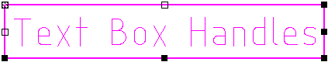

Handles on text boxes appear as an X square, a hollow square, or a solid square.

- An X handle indicates the origin of the text box. The origin is defined by the horizontal and vertical justification settings. Dragging an X handle moves the text box

- The hollow handles are used to move the text box. The origin point moves with the textbox.

- The solid handles are used to resize the text box. The origin point remains in its current location while the text box is resized.
Text Labels

Text labels are associated with an element or object. If you move the element or object, the text label moves with it. You can create text labels in a document by double-clicking an element or object while using the Select Tool. A text label appears near the element so that you can type text. The default position of the label is top center on all elements, except for closed elements, such as a circle or rectangle. The default position on closed elements is the center of the element. Once you have completed entering the text that you want, the label orients itself along linear elements.

To create a text label
- Choose the Select Tool from the Draw toolbar.

- Double-click an element or object. (1)

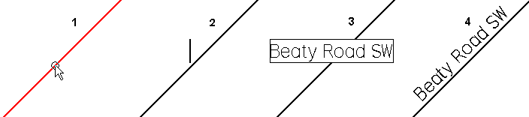

A small, blinking pointer (2) appears near the element or object. For a closed element, the pointer appears in the center of that element.

- Set desired text settings such as font and font size in the Text Box ribbon bar.

- Type the text in the label. (3)

- Click outside the label to complete it. (4)
The text label rotates to align with the element or object to which it is associated.

Note: The text label is associated to the element or object. If the element or object is moved, the label moves with it. If it is deleted, the label will also be erased.
To reposition only the text label

- Choose the Select Tool from the Draw toolbar.
- Select the text label. (1)

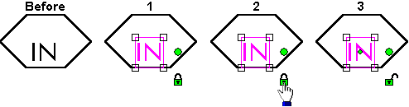

- Click the lock handle (2) to unlock it. (3)

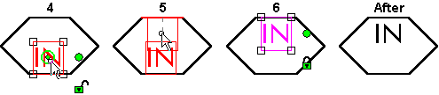

- Drag the text label to new location. (4-5-6)
The text label is still associated to the element or object. If the element or object is moved to a new location, the text label moves with it maintaining its new relative position.

Balloon Command
This tool, found on the Dimension toolbar, places a balloon containing text. You can use balloons to refer to an element or a point in free space. You can set options for controlling the size and shape of the balloon, text presentation, and leader display.

The balloon font, font style, and font size are controlled from the Text tab of the Format Dimension dialog box. Individual balloon settings can be set by accessing right-click> Properties. The balloon terminator settings are controlled with the Terminator and Symbol tab of the Format Dimension dialog box.

Balloon Ribbon Bar
The Balloon ribbon bar is used to adjust the shape of the balloon and the text within the balloon.
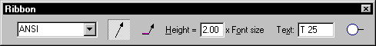
Dimension Style

Dimension Style
Lists and applies the available styles.

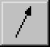 Leader
Sets or hides the display of a leader line from the balloon.

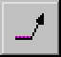 Break Line
Places a horizontal break line into the leader.

Height
Specifies the height of the balloon. The actual height of the balloon is the value you enter multiplied by the dimension text height.

Text
Specifies the text note you want shown inside the balloon.

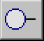 Shape
Specifies which balloon shape you want from the list of available shapes.

To place a balloon
- Click the Dimension command on the Main toolbar. The Dimension toolbar displays.
- Select the Balloon command from the Dimension toolbar.

- Set desired balloon settings in the Balloon ribbon bar.

- In the Balloon Text box, type the text you want to appear in the balloon.

- To place a balloon with a leader, click where you want to place the terminator end of the leader. The terminator end can be on an element or a point in free space. The default terminator used when an element is selected is an arrow.

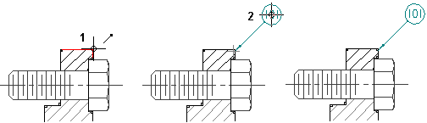

- Click where you want to place the balloon end of the leader.

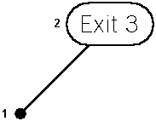

The default free space terminator is a dot.

Leader Command

The Leader command adds a leader to an annotation or to another leader. You can place either end of the leader first: the annotation end or the terminator end. The Leader ribbon bar is used to set the dimension style and toggle the break line on and off.

You can attach the annotation end of a leader to one of the following:

- Text box
- Balloon
- Another leader on a dimension or annotation
- You can place the terminator end of a leader in one of the following ways:
- Attach it to an element
- Place it in free space

To add a leader
  - Click the Dimension command on the Main toolbar, causing the Dimension toolbar to display.
  - Select the Leader command from the Dimension toolbar.
  - Click a text box, callout, or another leader to place the annotation end of the leader.
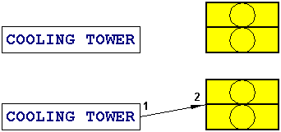

  - Click any element to place the terminator end of the leader, or click in free space.

Leader Ribbon Bar

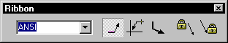
Dimension Style

Dimension Style
Lists and applies the available styles.

Break Line
Displays a horizontal break line at the notation end of a leader.

Automatic Shape Connection Behavior
Specifies automatic, shape-changing connection point behavior for the notation (end) reference. If the option is selected, the notation end of the leader uses information from the notation object in combination with the current leader position to determine the attachment point and break line direction. If the option is not selected, the notation end of the leader attaches to the point on the notation object that was selected when the leader was created, and the break line direction will not automatically break away from the notation object.

Break Line Along
If the option is selected, the break line displays at an angle along the notation object according to information provided by the object. For example, if a text box is at an angle, the break line displays parallel to the text box at the same angle. If the option is not selected, the break line remains in a horizontal position regardless of the angle of the notation object.

Notation Object Attachment Lock
Locks the notation end of the leader to the notation object so that any drag/modify operations on the leader will not detach it from the object.

Graphic Object Attachment Lock
Locks the graphic end of the leader to the graphic object so that any drag/modify operations on the leader will not detach it from the object.

Dimension Tools

Driving and Driven Dimensions

Driving Dimension
A dimension that exercises control over the size or location of the element it is associated with. Modifying the dimension changes the drawing objects.

Driven Dimension
Dimensions that are not driving dimensions are called driven dimensions. The value of a driven dimension is controlled by the element it refers to. If the element changes, the dimensional value updates.

Change a Driven Dimension to a Driving Dimension

- On the Tools menu, set the Maintain Relationships command so it is checked.

- Select the driven dimension you want to change.

- On the ribbon bar, click the Driving/Driven button. The color of the dimension changes to indicate a driving dimension.
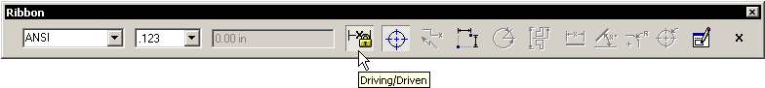

Notes:
- To place a driving dimension, you must set Maintain Relationships on the Tools menu, select an element, and then click a dimension command on the Dimension toolbar; the dimension that you place by default should be a driving dimension.
- To change a driving dimension to a driven dimension, select a driving dimension and click the Driving/Driven button. Or this method can toggle it the other way – Driving to Driven if there is a need to allow the elements to control the dimension.
- To set the colors for driving and driven dimensions, select the dimension and click Properties on the shortcut menu. Then set the options you want on the Properties dialog box.

Placing Dimensions

To dimension elements, choose one of the dimension commands from the Dimension toolbar, and then select the elements or keypoint to be dimensioned. As dimensions are being placed, the software shows a temporary, dynamic display of the dimension. This temporary display shows what the new dimension will look like if the current mouse cursor position is selected. The dimension orientation changes depending on where the mouse cursor is moved.

SmartDimension

Places a dimension for the following:

- Length and angle of a line
- Radius and diameter of a circle
- Length, angle, radius, and diameter of an arc
- Radius of an ellipse or curve
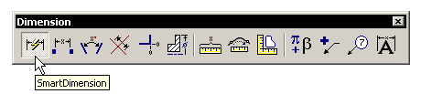

Distance Between

The Distance Between command places a linear dimension that measures the distance between elements or key points. You can place linear dimensions in stacked or chained dimension groups.

To dimension between two points
- From the Dimension toolbar, select Distance Between.
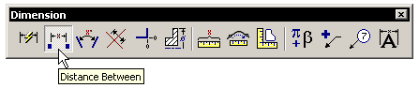
- Select an element or keypoint to identify the origin element (A).
- Choose an element or keypoint to measure to (B).
- Move the mouse cursor where the dimension is to be placed. The dimension dynamically follows the movement of the mouse cursor.
- Click to place the dimension (C)
- Right click to finish the command

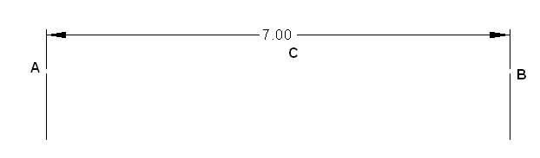

Angle Between

Places a dimension that measures the angle between elements or key points. You can place angular dimensions in stacked or chained dimension groups.

To dimension the angle between two lines
- From the Dimension toolbar, select Angle Between.
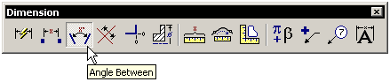
- Select an element or keypoint to identify the origin element (A).
- Choose an element or keypoint to measure to (B).
- Move the mouse cursor where the dimension is to be placed. The dimension dynamically follows the movement of the mouse cursor.
- Click to place the dimension.
- Right click to complete the command.

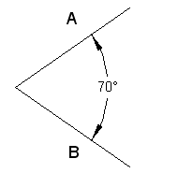

Coordinate Dimension

Places a dimension that measures the distance from a common origin to one or more key points or elements. The coordinate dimensions that refer to the common origin are members of a coordinate dimension group.

You can place coordinate dimensions in any order and on either side of the origin with respect to the dimension axis. You can also add additional coordinate dimensions to existing coordinate dimension groups, (a group of dimensions that measure locations from a common origin).
- From the Dimension toolbar, select Coordinate Dimension.
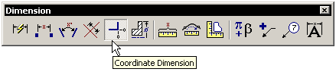
- Select an element or keypoint to identify the origin element (A).
- Select the additional elements or keypoints (B, C, D).
- Right click the mouse to complete the command.
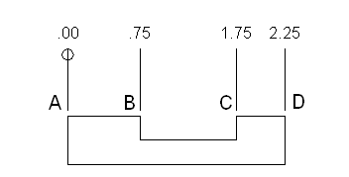

Drawing Editor Symbols

Symbols Overview

A frequently used drawing object can be stored in one document and placed in other documents at a scale, position, and orientation that you define. Graphic data used in this way is called a symbol. Symbols increase drawing productivity because they allow you to access existing graphic data quickly and easily. With a symbol, you can place graphic information repeatedly without re-creating it. Symbols save you time by eliminating the need to re-create information, as well as help you maintain accurate graphic data throughout a project. Symbols are contained in documents with a .sym extension.

Creating Symbols
A symbol is a document with a .sym extension. You can create a symbol by selecting the desired geometry and clicking the Create Symbol button on the Draw toolbar.

Default Behaviors
The default behaviors for symbols that you create are:

- 90° rotation angles. You can press the left and right arrow keys on the keyboard to rotate symbol 90° while placing.
- One drag point at the origin point defined when symbol is created.
- Scale, mirror, and rotate handles display when symbol has been selected.
- Will not automatically align or lock to other objects.

To create a symbol
  - Using the Select Tool , pick the elements that the symbol is to be made from.

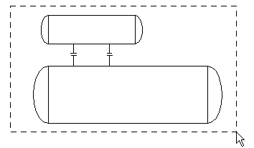
  - On the Draw toolbar, click the Create Symbol button.
  - Click a point on the drawing sheet to define the origin of the symbol.

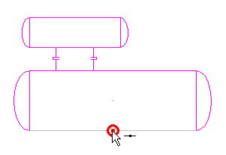
  - In the Save As dialog box, select the directory where you want to save the symbol.
  - Type the name that you want for the symbol. The software saves the document with a .sym extension. Click the OK button.

Placing Symbols

Symbol Options
Before placing a symbol, you can set an option to link or embed the symbol when you drag and drop it onto the drawing sheet. You can do this by clicking the Options command on the Tools menu and then setting the option you want on the Symbols tab.

To place a symbol
- Select a symbol from the Symbol Explorer.
- Using the left mouse button, drag the symbol from the Symbol Explorer window into the active document.
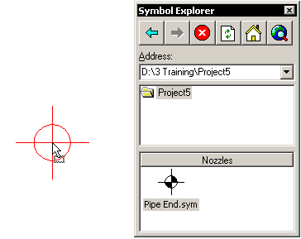

Notes:
- When you click a symbol in the Symbol Explorer to drag it into a document, the pointer attaches to the origin of the symbol. The origin was defined when the symbol was originally created.

- Dimensions within a symbol do not display when it is dropped into a document.

To place multiple copies of a symbol

- Select the desired symbol with the mouse by clicking it with the left mouse button a single time in the Symbol Explorer.
- Move the cursor to the desired position in the drawing and click to place the symbol.
- The symbol will remain active until the right mouse button is selected or another symbol is chosen from the Symbol Explorer.

To place multiple copies using the Stamp method

- Select a symbol with the right mouse button, and while holding it down, drag the symbol into the document.
- Release the right mouse button in the desired location of the first symbol.
- On the displayed shortcut menu, click Stamp Here.
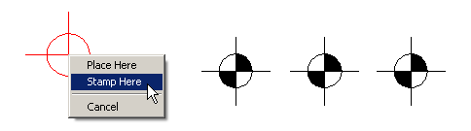
- Click another point in the document (with the left button) to place a copy of the symbol. You can click as many points as you want to place multiple copies of the same symbol.
- Click the right mouse button when you are finished placing the symbol.

Note: If you decide that you do not want to place several copies of a symbol, you can click Place Here on the shortcut menu. This places only one instance of the symbol.
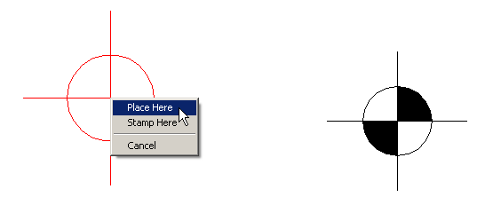

Symbol Placement Behavior

Drag Points
A drag point is the point to which the mouse cursor attaches to a symbol for dragging and dropping. A symbol can have multiple drag points, which can be toggled using the up and down arrow keys as the symbol is being dragged into the drawing.
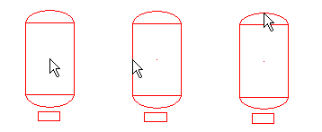

Rotation
When you drag a symbol or align it to an element, you can press the left and right arrow keys on the keyboard. This rotates the symbol in 90° increments by default. Some symbols are designed to rotate at different increments. A symbol defined with a rotation of 0° will not rotate using the arrow keys.

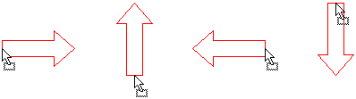

Alignment
Some symbols are created with a special alignment behavior. This behavior allows the symbol to automatically rotate and align itself parallel to another graphical object during drag and drop placement or when the symbol is repositioned after placement.

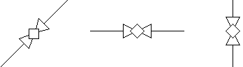

Creating a simple parametric symbol for a Pipe End

Draw the Graphics:

- Start Drawing Editor.
- Make sure that Tools – Maintain Relationships is turned on.

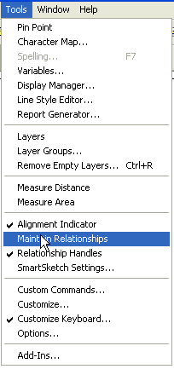

- Select Tools – SmartSketch Settings and make sure that Mid Point is checked.

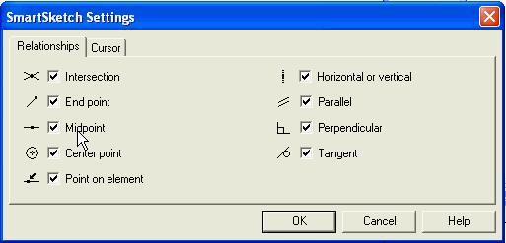

- Select the line command and place a vertical line on the sheet.
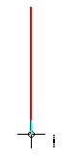

- Reset (right mouse click) and place a horizontal line on the sheet.

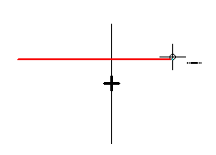

- Display the relationship toolbar by clicking on the Main toolbar Relationship button.

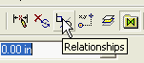

- Select the Connect relationship command.

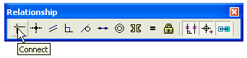

- Move your mouse over the horizontal line until you see the midpoint glyph displayed and click the left mouse button.

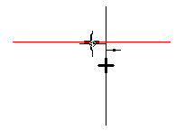
- Move your mouse over the vertical line until you see the midpoint glyph display and click the left mouse button.

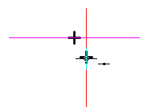

- The horizontal line should move so that its midpoint is coincident with the vertical lines midpoint.

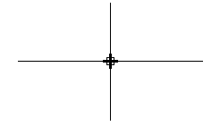

- Select the Equal relationship command.

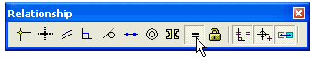

- Click on the vertical line and then the horizontal line.
- The vertical line and the horizontal line should become the same length.

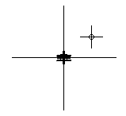

- Turn off the Relationship toolbar by clicking the red X in the titlebar of the toolbar.
- Select the circle command on the Draw toolbar and move over the intersection of the two lines. Click the left mouse button when the midpoint glyph is displayed to begin the circle.

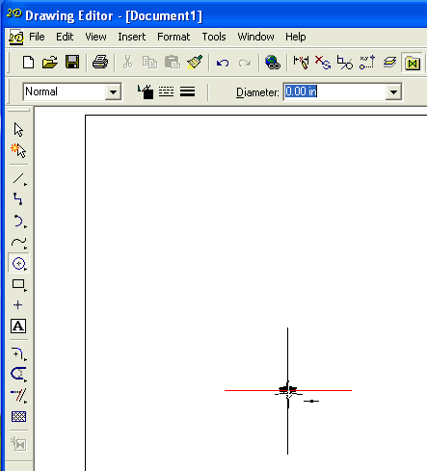

- Move the mouse some distance and click again to place the circle.
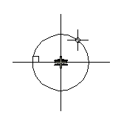

- Select the Fill command on the Draw toolbar.

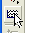

- On the ribbon bar for the Fill command, select a Solid style and select black as the color.

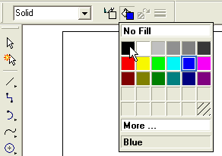

- Click in the upper right and lower left quadrants of the circle to fill them.

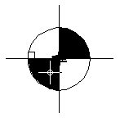

Add the Dimensions:

- Select Tools – Layers to display the Layers ribbon bar.

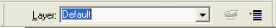

- Type in Dimensions to create a layer for the dimensions.

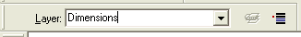

- Display the Dimension toolbar by clicking the Dimension button on the Main toolbar.

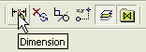

- Select the SmartDimension command.

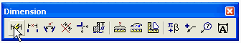
- Dimension the diameter of the circle and the horizontal line. Both dimensions should be black (driving dimensions).
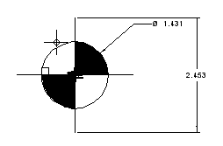

- Select Tools – Variables to display the Variable Table. There should be two entries, one for the diameter of the circle and one for the length of the lines.

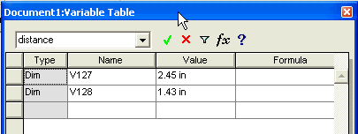

- In the Formula field for the dimension for the length of the lines, enter ‘1.5*V128’ (note – Replace V128 with the actual name of the circle dimension displayed in your Variable Table) and close the dialog. The two lines should resize with respect to the circle.

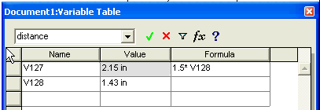

- Select the dimension for the circle diameter and change its value in the dimension ribbonbar to verify that the formula is being correctly applied.
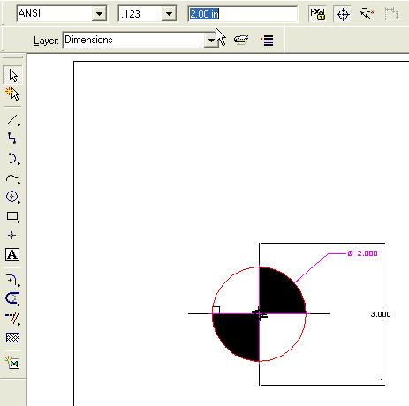

Create the Symbol:

- Select all of the objects using Edit – Select All or by using the Select Tool.
- Click the Create Symbol command on the Draw toolbar.

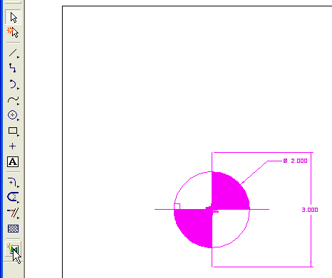

- Click at the center point of the circle (the intersection of the two lines) to set the symbol origin.

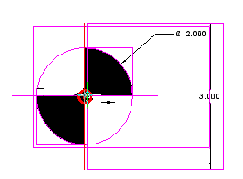

- Enter a name and select the location in the File – SaveAs dialog.

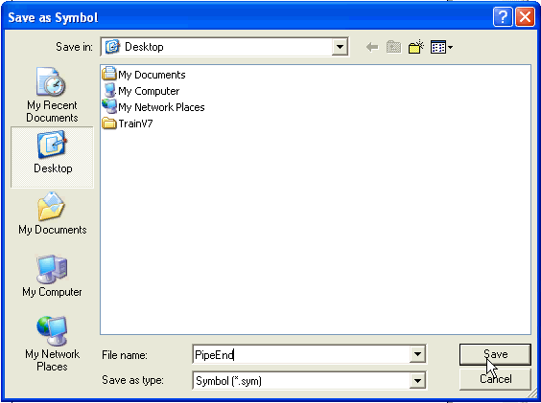

Set the symbol parameters and behaviors:

- Open the symbol by selecting File – Open and browse to the symbol file you just created.
- Select Tools – Add-Ins to display the Add-In Manager dialog and turn on the Symbol Authoring Tools add-in.

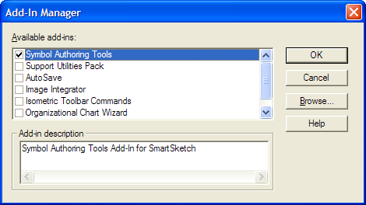

- On the Symbol Authoring toolbar, select Symbol Properties.

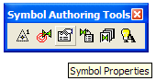

- On the General tab, turn off Scale handles and Mirror handles.

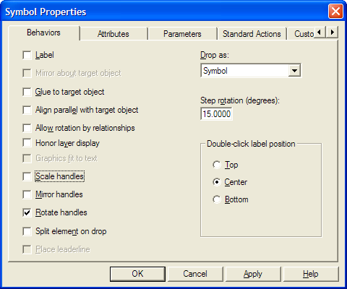

- Click on the Parameters tab.
- Make sure that the dimension for the Circle is selected and in the parameter name field enter OPD. Click Apply and OK.

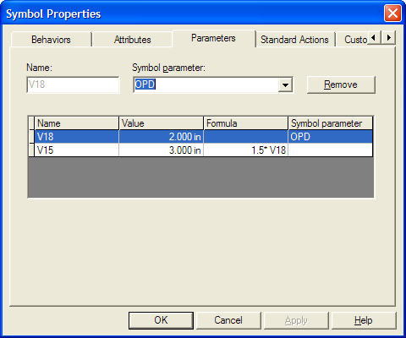

- On the Layers ribbon bar (if not displayed, use tools – Layers to display it), select the Default layer in the combo box; then click the Display layers button.

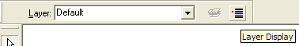

- Turn off the display of the dimensions layer and click OK.

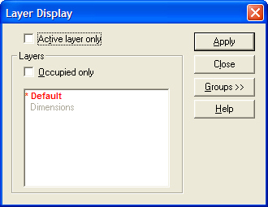

- Save and Close the symbol file.

Place and Test the symbol:

- Display the Symbol Explorer by clicking on the Symbol Explorer button on the Main toolbar.

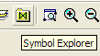

- Use the Symbol Explorer to locate and drag in your symbol.

- In the Attribute Viewer, set the value of OPD to 3 in and verify that the symbol resizes. Change the value and verify that the symbol resizes again.
